Module Name: Login Page - Functional & Input Condition Test Cases
Test Case ID: PTA_01
Webpage URL: https://practicetestautomation.com/practice-test-login/
• Scenario ID: 1a
Scenario: Login with valid credentials
Test Steps:
1. Open the Login page
2. Enter Username: student
3. Enter Password: Password123
4. Click Submit button
Screenshots:
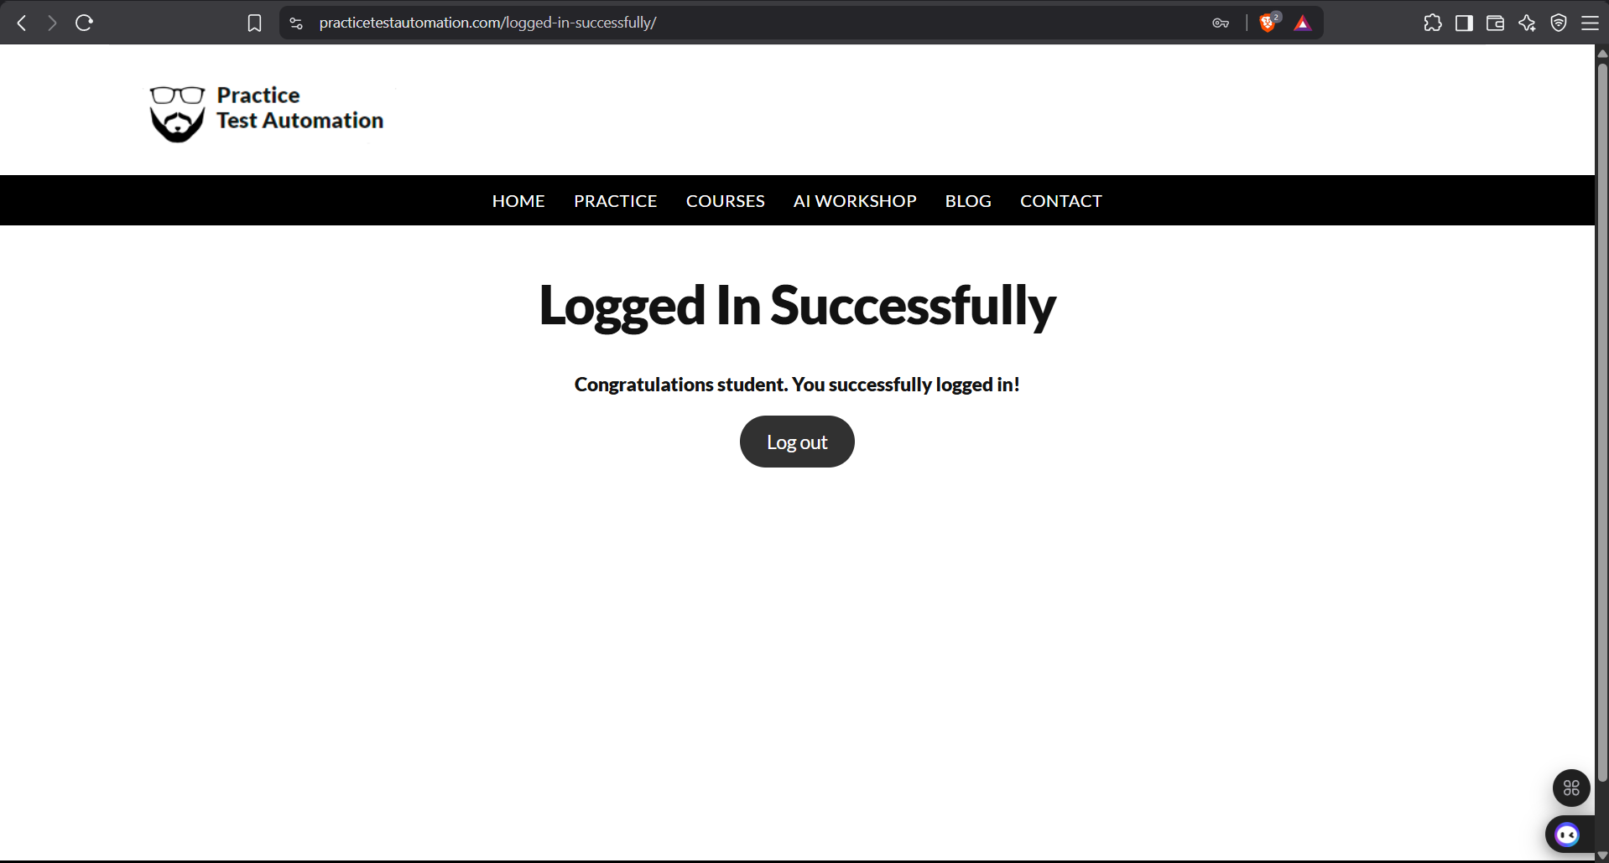
• Scenario ID: 1b
Scenario: Login with invalid username
Test Steps:
1. Open the Login page
2. Enter invalid Username: incorrectUser
3. Enter valid Password: Password123
4. Click Submit button
Screenshots:
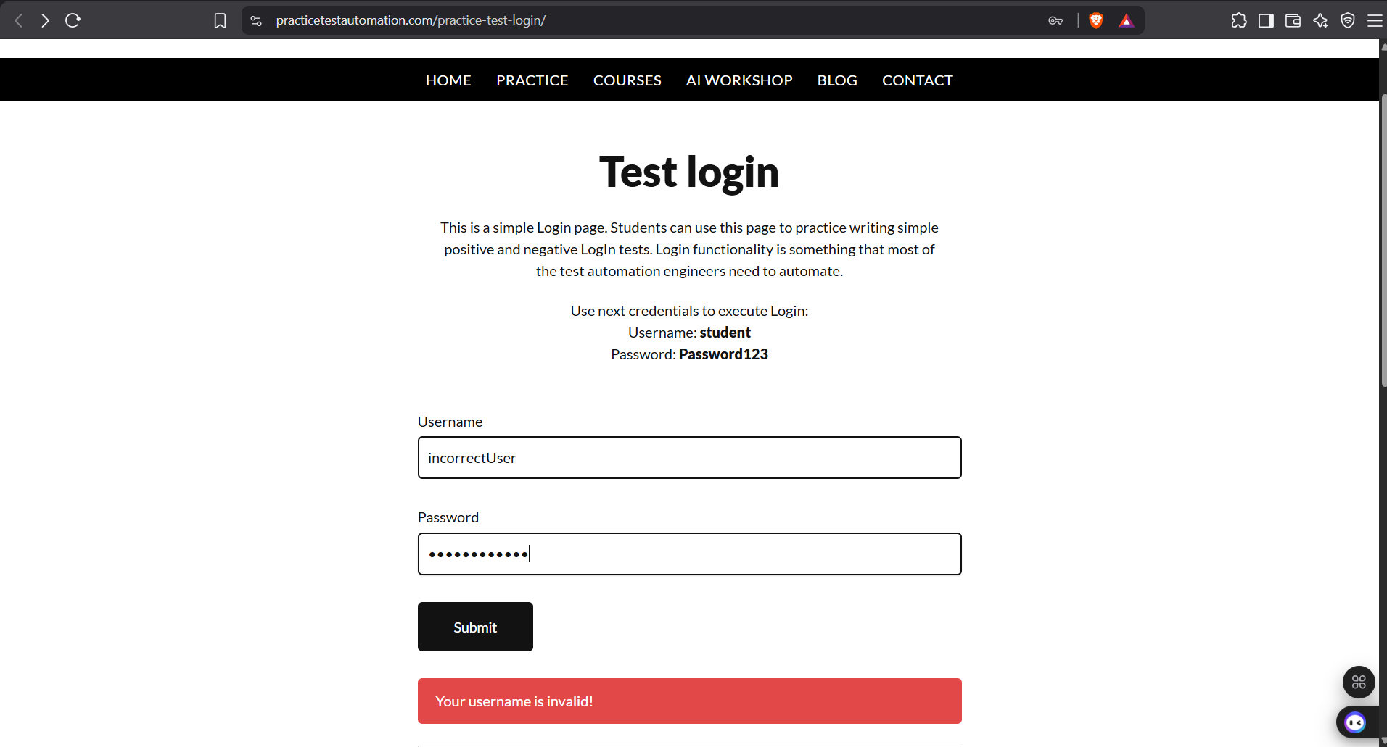
• Scenario ID: 1c
Scenario: Login with invalid password
Test Steps:
1. Open the Login page
2. Enter valid Username: student
3. Enter invalid Password: incorrectPassword
4. Click Submit button
Screenshots:
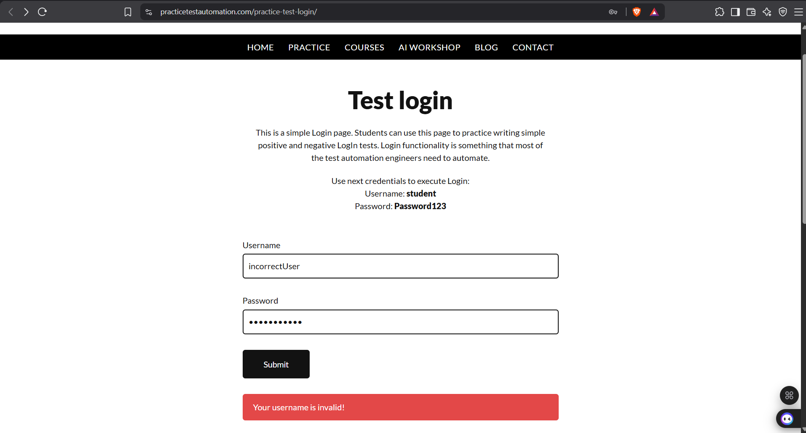
• Scenario ID: 1d
Scenario: Login with both invalid credentials
Test Steps:
1. Open the Login page
2. Enter invalid Username: wrongUser123
3. Enter invalid Password: wrongPass456
4. Click Submit button
Screenshots:
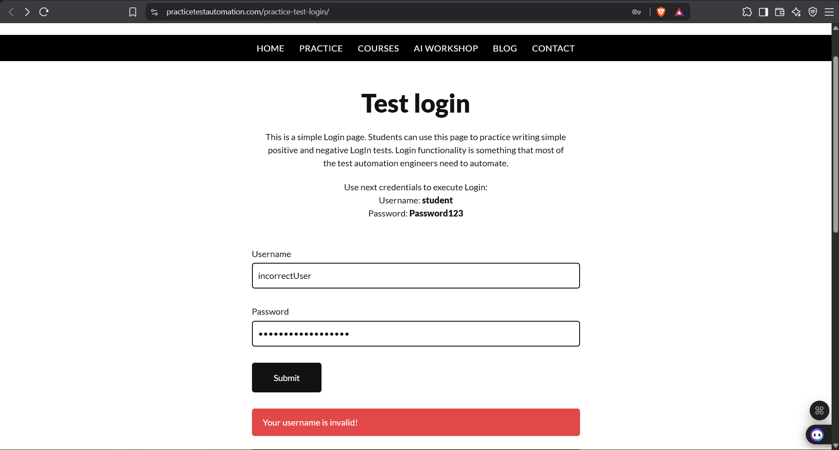
• Scenario ID: 1e
Scenario: Login with empty username
Test Steps:
1. Open the Login page
2. Leave Username field blank
3. Enter any Password
4. Click Submit button
Screenshots:
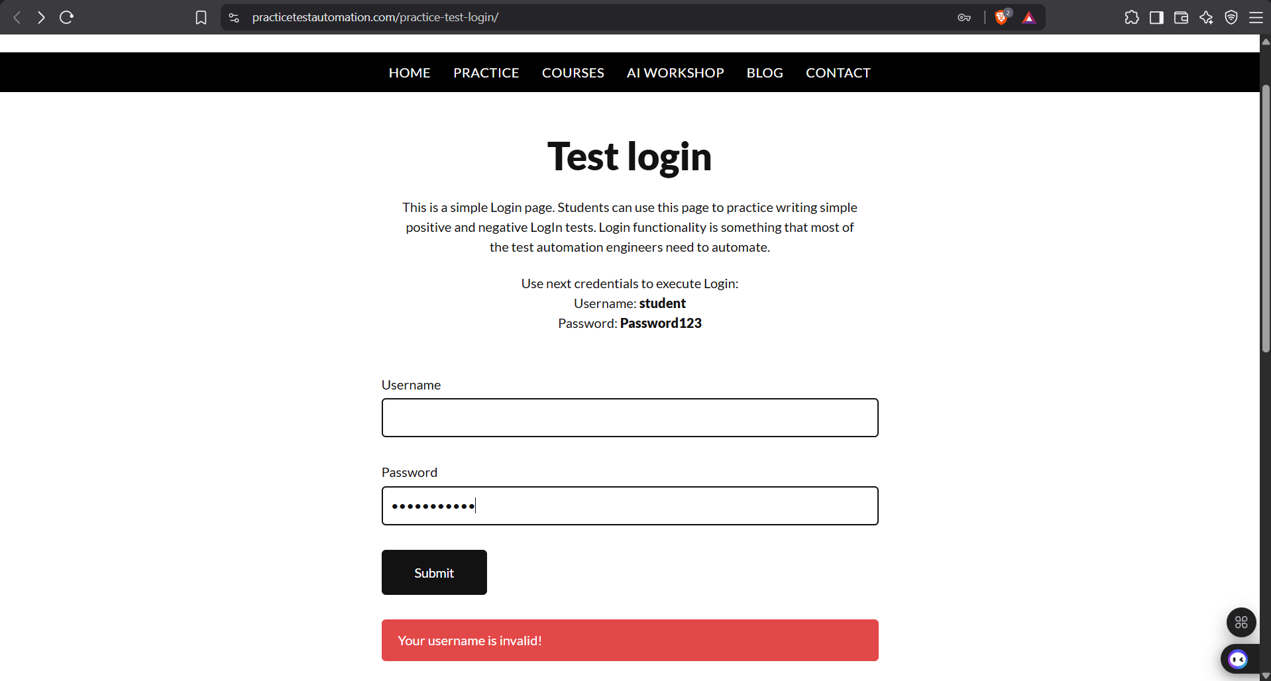
• Scenario ID: 1f
Scenario: Login with empty password
Test Steps:
1. Open the Login page
2. Enter valid Username: student
3. Leave Password field blank
4. Click Submit button
Screenshots:
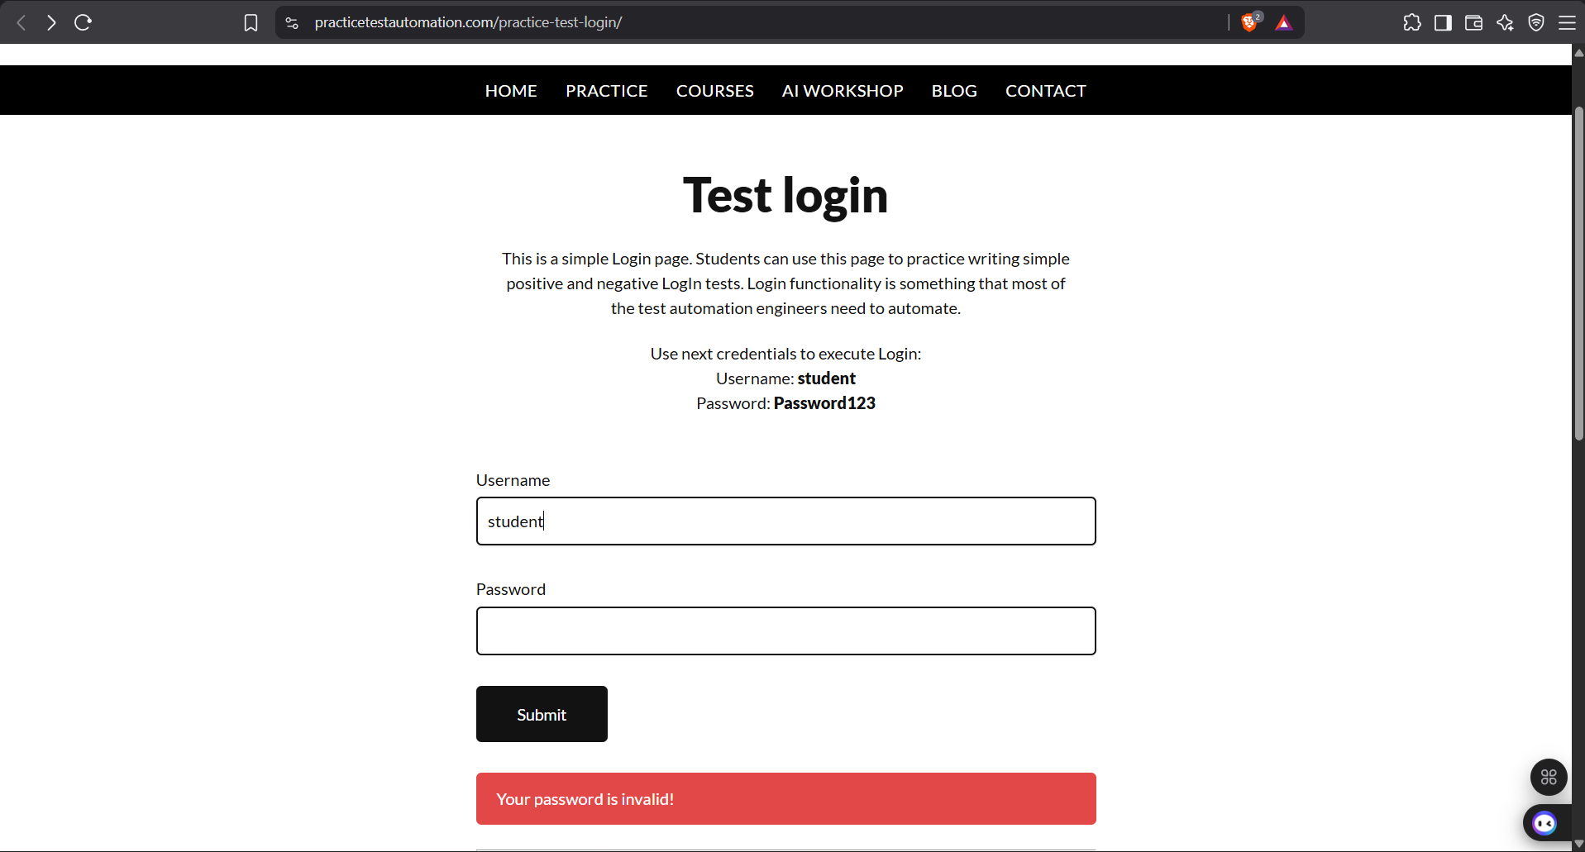
• Scenario ID: 1g
Scenario: Login with both fields empty
Test Steps:
1. Open the Login page
2. Leave both Username and Password blank
3. Click Submit button
Screenshots:
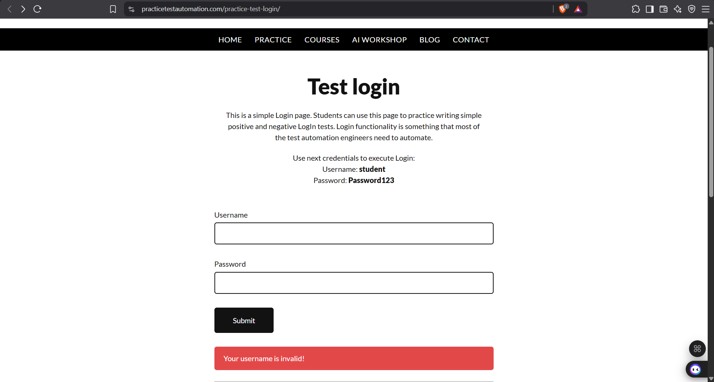
• Scenario ID: 1h
Scenario: Login with special characters
Test Steps:
1. Open the Login page
2. Enter Username with special characters: stud@#$%ent
3. Enter any Password
4. Click Submit button
Screenshots:
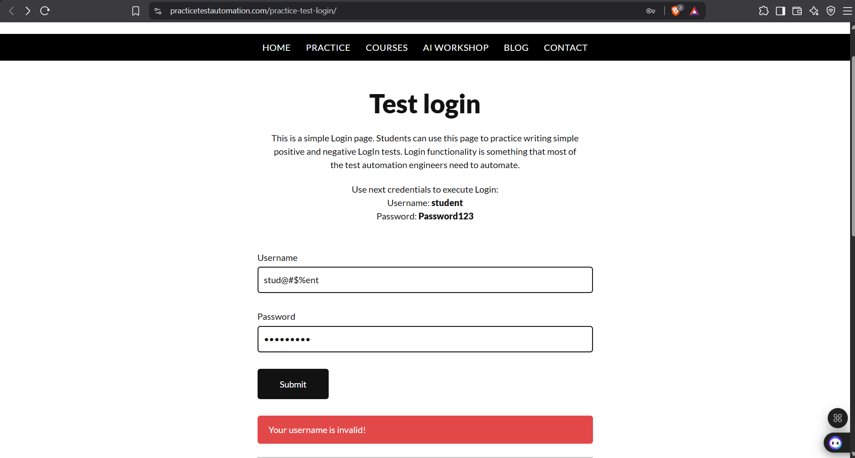
• Scenario ID: 1i
Scenario: Login with case changes in username
Test Steps:
1. Open the Login page
2. Enter Username with altered casing: Student
3. Enter valid Password: Password123
4. Click Submit button
Screenshots:
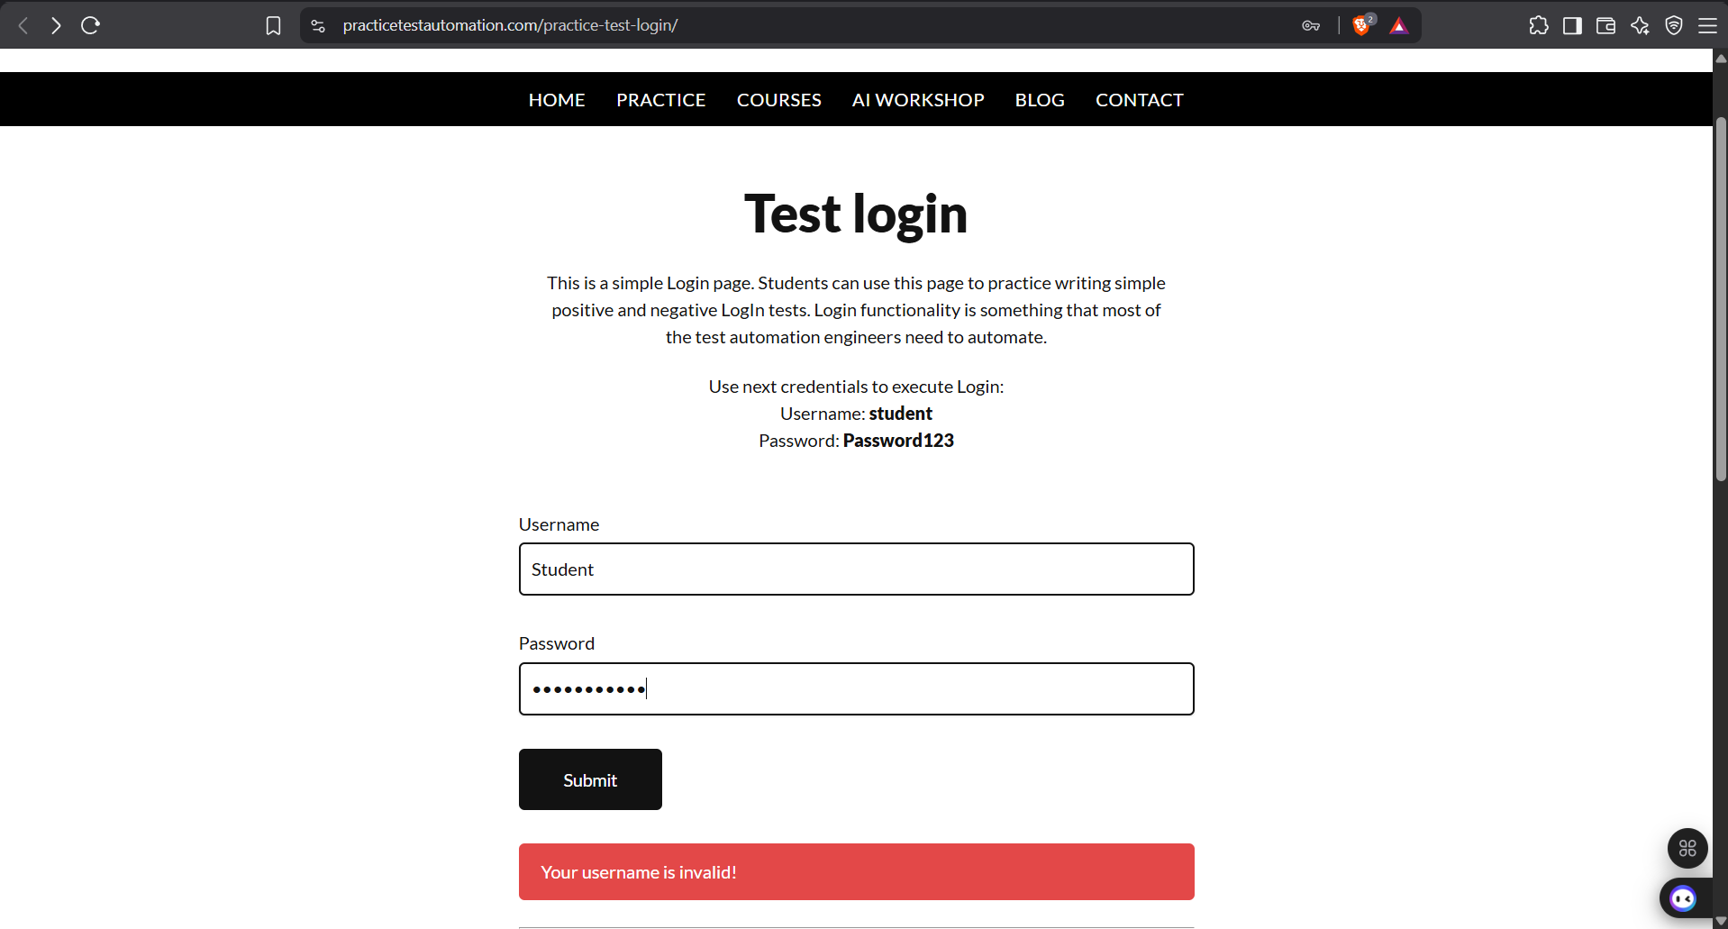
• Scenario ID: 1j
Scenario: Login with case changes in password
Test Steps:
1. Open the Login page
2. Enter valid Username: student
3. Enter Password with altered casing: password123
4. Click Submit button
Screenshots:

• Scenario ID: 1k
Scenario: Login with only whitespace inputs
Test Steps:
1. Open the Login page
2. Enter only space characters in Username and Password fields
3. Click Submit button
Screenshots:
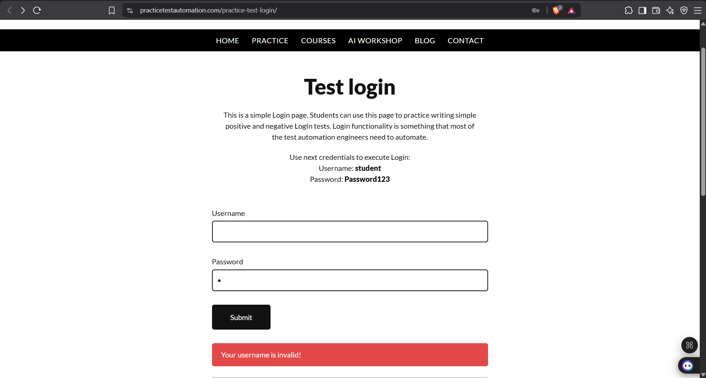
• Scenario ID: 1l
Scenario: Login with very long username (Boundary)
Test Steps:
1. Open the Login page
2. Enter very long Username (60+ characters)
3. Enter valid Password: Password123
4. Click Submit button
Screenshots:
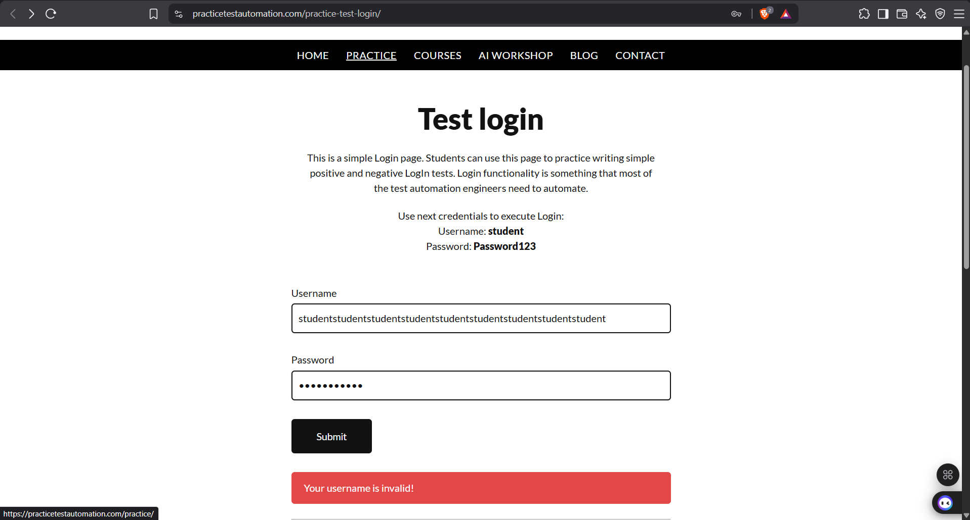
• Scenario ID: 1m
Scenario: Logout from success page
Test Steps:
1. Login with valid credentials
2. On success page click Log out button
3. Observe redirection to Login page
Screenshots:

• Reference Screenshot: Empty Login Page
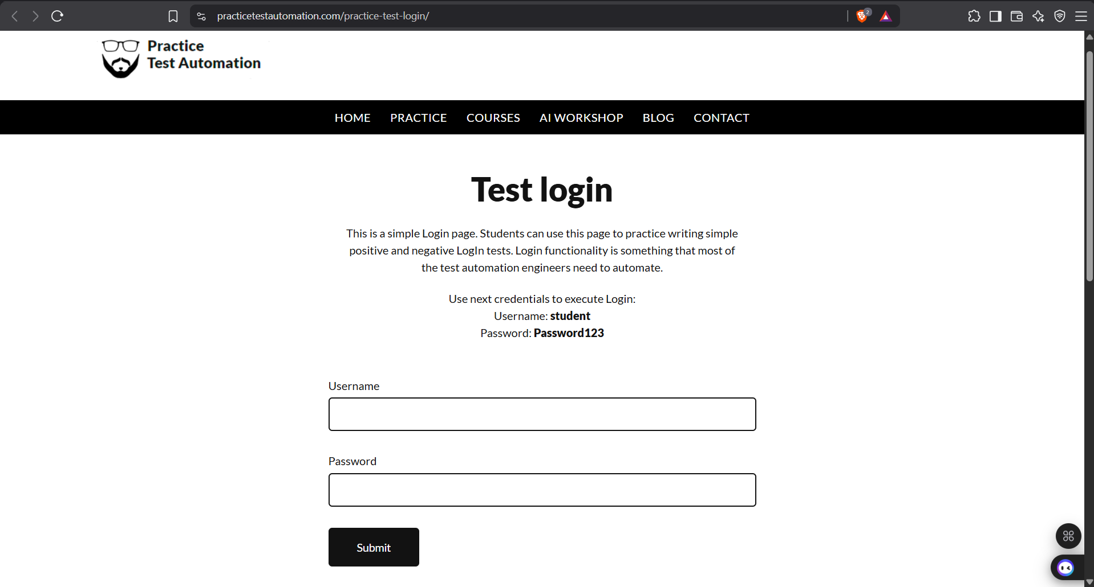
• Summary Of Test Results:
Total Test Cases- 13
Passed- 13
Failed- 0
Pass %- 100%
• Conclusion and Recommendations:
Pass Rate: 100%. All test cases covering multiple input conditions executed successfully.
• Issues Found
No issues / defects were found during testing. The application correctly validates all tested input conditions and displays appropriate success and error messages.
• Recommendations
1. Continue maintaining clear and distinct error messages for better usability.
2. Consider adding rate-limiting or CAPTCHA for production-grade security (currently not present).
3. This page remains an excellent practice site for both manual and automated login testing.
• Bug Reports:
No bugs were logged. All 13 test cases passed successfully.
Field | Description
Bug ID | -
Title | No defects found
Module | Login
Severity | -
Status | N/A – All Passed

Prepared By: Fegade Parth
Date: 02-August-2026

